Best TorrentGalaxy Proxy — Risks, Reality & Safer Alternatives
If you’ve searched for the best TorrentGalaxy proxy, you’re not alone. TorrentGalaxy (TGx) became one of the popular torrent sites after other big names like KickassTorrents and ExtraTorrent were shut down. With its large library of movies, TV shows, games, and software, it quickly attracted global users.
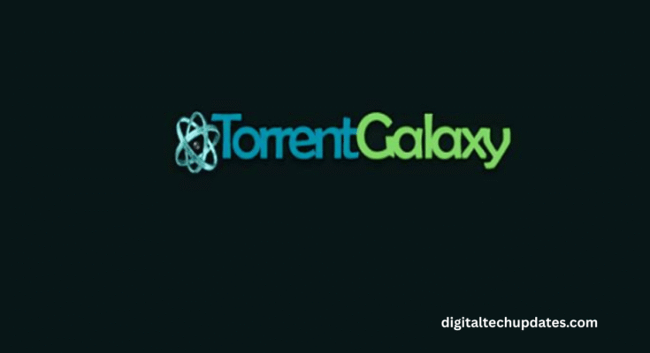
However, like most torrent sites, TorrentGalaxy faces blocks and takedowns in many countries. To bypass these restrictions, users often turn to “proxies” or “mirror sites” that claim to restore access. But before you use them, it’s important to understand the risks of TorrentGalaxy proxies and explore safer options.
Why Do People Search for TorrentGalaxy Proxies?
To access TGx when it’s blocked by ISPs or authorities
To keep using a familiar torrent site interface
To download free movies, games, or software
Out of habit from years of torrenting culture
But not all proxies are safe — in fact, most are risky clones or scams.
The Hidden Dangers of TorrentGalaxy Proxy Sites
⚖️ Legal Risks – Downloading copyrighted content through proxies may violate copyright law, leading to ISP warnings or fines.
🦠 Malware & Viruses – Proxy sites are notorious for fake download buttons, popups, and malicious scripts.
🔍 Privacy Exposure – Torrenting reveals your IP address, which can be logged or misused.
❌ Poor Content Quality – Many mirrors host mislabeled or corrupted files.
💸 Ethical Concerns – Piracy undermines revenue for creators and industries.
Safer, Legal Alternatives to TorrentGalaxy
Instead of hunting for the best TorrentGalaxy proxy, try these safer platforms that give you the same benefits without risks:
🎬 Movies & TV Shows
Netflix, Amazon Prime Video, Disney+ Hotstar, Apple TV+, HBO Max — high-quality streaming.
Free options: Tubi, Pluto TV, Crackle, MX Player (ad-supported).
🎮 Games & Software

Steam, Epic Games Store, GOG — official, safe downloads.
Open-source: SourceForge, GitHub projects.
📚 Books & Learning
Project Gutenberg, Open Library, Internet Archive — free ebooks.
Kanopy, Hoopla — free with a library card.
🎶 Music
Spotify, YouTube Music, SoundCloud — free or subscription-based.
The Smart Takeaway
Searching for the best TorrentGalaxy proxy may feel like a shortcut to free content, but it comes with serious risks: malware, legal issues, and privacy breaches. Instead, turn to licensed streaming services, ad-supported free platforms, and public-domain resources.

