MagnetDL Proxy — What It Is, Risks, and Safer Alternatives
If you’ve come across the term MagnetDL Proxy, you’re likely searching for ways to access MagnetDL, a torrent indexing site popular for its simple design and magnet link support. Like other torrent platforms, MagnetDL became known for sharing movies, TV shows, games, and software — but without proper licensing.
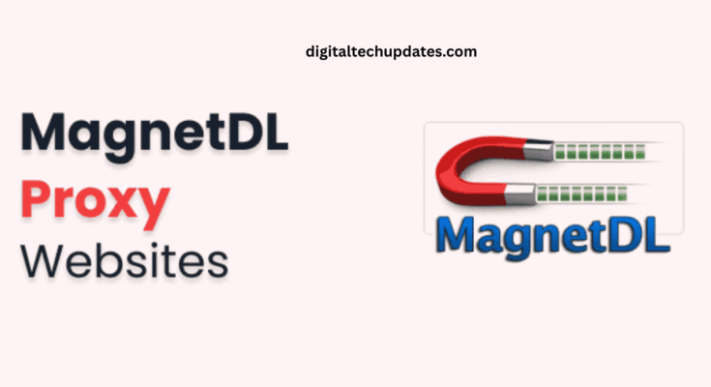
As a result, it has faced restrictions and takedowns in several countries. To bypass these blocks, people often look for MagnetDL proxies or mirror sites. But before you try one, it’s important to understand the risks and the better, legal alternatives available today.
Why do people search for MagnetDL proxies?
To access content blocked in their region
To find a familiar torrent indexer interface
For free downloads without subscriptions
Out of habit from using torrent sites in the past
But proxies and mirrors aren’t as safe as they look.
The Hidden Risks of MagnetDL Proxy Sites
Legal consequences – Downloading copyrighted material can breach copyright law, exposing you to fines or ISP warnings.
Malware & phishing – Many proxy clones embed ads, popups, and fake buttons that can install malicious software.
Privacy risks – Torrenting exposes your IP address to peers and trackers, making your activity traceable.
Unreliable content – Fake files, mislabeled downloads, or low-quality versions are common.
Ethical issues – Piracy reduces revenue for creators and industries producing the content.
Safer, Legal Alternatives to MagnetDL
If you’re searching for the best MagnetDL proxy, try these secure options instead:
🎬 Movies & TV Shows
Netflix, Amazon Prime Video, Disney+ Hotstar, HBO Max, Apple TV+
Free & ad-supported platforms: Tubi, Pluto TV, Crackle, MX Player
🎮 Games & Software
Steam, Epic Games Store, GOG — DRM-free and safe
SourceForge, GitHub — open-source and freeware
📚 Books & Study Material
Project Gutenberg, Internet Archive, Open Library — free, legal downloads
Kanopy, Hoopla — free with library cards
🎶 Music
Spotify, YouTube Music, SoundCloud — legal, free or premium plans
Key Takeaway
Searching for a MagnetDL proxy may look like an easy solution, but proxy and mirror sites come with hidden dangers: malware, privacy leaks, legal risks, and poor-quality downloads. Instead, opt for legal streaming services, open-source software, and public-domain resources.

