Putlocker Proxy — What It Means, Why People Search for It, and Why You Should Avoid Mirror Sites
Short answer: Putlocker was a widely known site for free movie and TV streaming. After repeated takedowns and blocks, many copycat “mirrors” and proxy sites have sprung up that claim to restore access. Searching for a Putlocker proxy might seem like a shortcut to free content, but these mirror sites carry significant legal, security, privacy and ethical risks. This guide explains what a Putlocker proxy is (high level, non-actionable), why people hunt for them, the dangers involved, and safe legal alternatives.
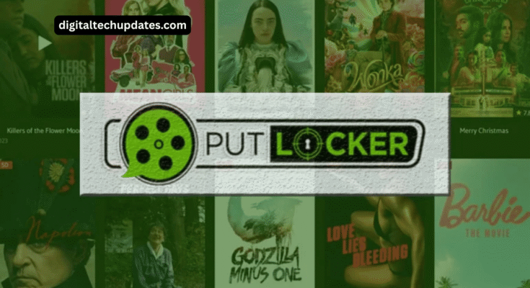
What was Putlocker?
Putlocker was part of a family of streaming/indexing sites that made movies and TV shows available to users for free—often without proper licensing or permission from content owners. The original Putlocker domain was taken down multiple times following legal pressure; as a result, many clones, mirrors, and proxy gateways appeared to replicate its functionality.
What is a “Putlocker proxy” or “mirror”?
Mirror: A copy of a website (same content, different URL) that’s published to replace or supplement the original site when it’s offline.
Proxy: A gateway that relays or forwards content so users can access another site indirectly.
Both are technical workarounds; they do not change the underlying legality of the content offered.
Why do people look for Putlocker proxies?
Typical (not legal) motivations include:
Free access to movies and TV shows without paying subscription fees.
Fast availability of recent releases.
No sign-up or subscription friction.
Those conveniences don’t remove the legal and security consequences.
The real risks of using Putlocker mirrors/proxies
1. Legal exposure
Accessing or downloading copyrighted films and shows without permission can violate copyright laws in many jurisdictions. Consequences range from ISP warnings to fines and — in rare or egregious cases — civil or criminal action.
2. Malware and scams
Mirror & proxy sites often monetize traffic with aggressive ads, fake “play/download” buttons, pop-ups, or prompts to install codecs/extensions. These are common infection vectors for:
Adware/spyware
Credential-stealing phishing pages
Ransomware or trojans
3. Privacy and tracking
Some clone sites log IP addresses and browsing behavior or push malicious browser extensions that harvest data. That information can be sold or used in identity fraud.
4. Poor content quality and reliability
Mirrors typically offer low-quality streams, mislabeled files, or broken links — and domains disappear overnight when law enforcement or hosts act.
5. Ethical and financial harm to creators
Piracy reduces revenue for filmmakers, actors, and the many professionals involved in content production. This can hurt investment in future content, particularly for smaller creators and independent studios.
How mirror/proxy networks typically operate (high-level, non-actionable)
Original domain is blocked or seized.
Operators or third parties publish the same content under a new domain or mirror.
Traffic is driven via SEO, social links, and link aggregation.
Revenue is made through ads, affiliate links, or deceptive downloads.
When that domain is blocked, the cycle repeats.
This “cat-and-mouse” dynamic produces dozens of short-lived, risky sites.
Red flags — how to spot a dangerous mirror or proxy (don’t click)
Multiple big, distracting “Play / Download” buttons that open other sites.
Prompts to install a browser extension, app, or suspicious “codec.”
Requests for social logins or credentials to “verify” your age.
Excessive pop-ups or forced redirects to third-party domains.
Newly registered domains with odd TLDs and no trustworthy WHOIS/owner information.
Claims like “watch new movie releases same day for free” — if it sounds too good to be true, it probably is.
Safer, legal alternatives to Putlocker-style mirrors
If you want movies and TV without the risks, choose legal channels:
Subscription streaming (best balance of quality & selection)
Netflix — global originals, movies, and series.
Amazon Prime Video — large catalog + rentals.
Disney+ / Hotstar — family & blockbuster content and regional offerings.
HBO Max / Max, Paramount+, Peacock — premium TV and movies.
Ad-supported legal platforms (free or low cost)
Tubi, Pluto TV, Crackle, Peacock free tier — legal ad-supported catalogs.
MX Player (select markets), Voot, and regional ad-supported services.
Rent or buy
Google Play Movies, Apple TV/iTunes, YouTube Movies — rent or purchase titles legally.
Library & public-domain sources
Kanopy, Hoopla, Internet Archive — many public-domain or library-licensed films free with a library card.
Practical safety tips if you accidentally land on sketchy sites
Don’t click “Download” or “Play” buttons that look suspicious.
Don’t install unknown browser extensions or apps.
Keep your OS, browser, and antivirus updated.
Use reputable ad-blockers and script blockers (they help but don’t make piracy safe).
Prefer official platforms with clear licensing and secure payment methods.
FAQs (short and shareable)
Q: Are Putlocker proxies illegal?
A: The proxies themselves are often unlawful in practice because they facilitate access to unlicensed content. Using them to stream or download copyrighted content is likely to violate local copyright laws.
Q: Can I get malware from mirror sites?
A: Yes — fake download buttons, popups, and malicious scripts are common on these sites.
Q: Will my ISP or authorities track me?
A: Enforcement varies by country. Some ISPs issue warnings or block access; some jurisdictions pursue more aggressive measures for repeated infringement.
Q: Is there any safe way to watch new releases for free?
A: Occasionally, yes—through official free trials, promotional windows on legal platforms, ad-supported legal services, or library streaming. Always use official channels.
Final thoughts
Looking for a Putlocker proxy might seem like an easy way to watch something for free, but the downsides are serious: legal exposure, malware risk, privacy loss, and real harm to creators. For reliable, secure, and ethical viewing, choose licensed streaming services, ad-supported legal platforms, or rental options. That keeps you safe and supports the people who make the content.

