How Much RAM is Best for PC Gaming

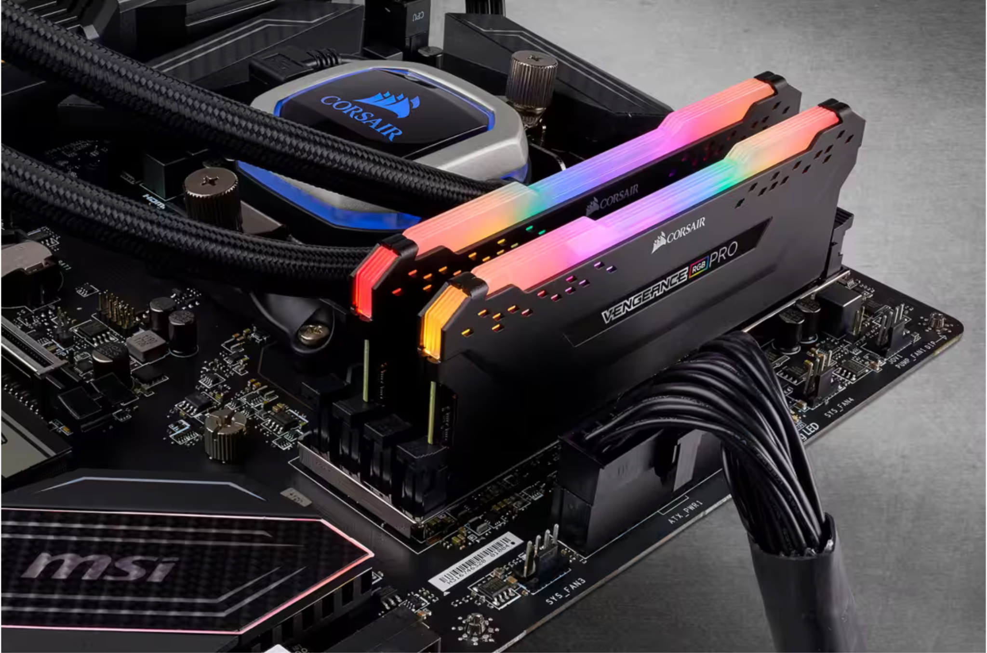
Figure 1Corsair Vengernce Pro 32GB DDR4 Memory, Credit: Corsair

In general, when talking about RAM (Random Access Memory), we're referring to the system memory (also called RAM) that the CPU uses to store and access data quickly. RAM (Random Access Memory) is an essential component of a gaming PC. It is responsible for holding the data that the CPU (Central Processing Unit) needs to access quickly, allowing faster processing speeds and smoother game performance. With technological advancements, games are becoming more demanding, and having enough RAM to keep up with them is crucial.

When it comes to PC gaming, VRAM (Video Random Access Memory) is just as important as regular RAM. VRAM is a specialized type of memory that is dedicated to the graphics card and is used to store and access the data that is needed for rendering images and videos on your computer screen.

This article will discuss how much RAM and VRAM you need for PC gaming in 2023.

How important is computer memory for PC gaming?
Computer memory is incredibly important for PC gaming. RAM allows the CPU to access data quickly so games run smoothly without lags or stutters. If your PC does not have enough memory, the CPU will have to rely on the slower hard drive or SSD to access data, which can significantly impact game performance.

How much RAM do you need for PC gaming in 2023?
There is no one-size-fits-all answer to this question, as the amount of RAM required for gaming in 2023 depends on the type of game, graphics settings, and the number of applications running simultaneously. Generally, 16GB of RAM is sufficient for most gamers. It allows you to run most modern games without any issues and gives you enough headroom for multitasking and running other programs simultaneously.

However, you might need more RAM if you're a content creator or professional. For example, if you work with video editing or rendering software, you'll need at least 32GB of RAM to work efficiently. Additionally, some newer games may require more than 16GB of RAM to run smoothly, particularly at higher resolutions.

16GB of RAM is sufficient for most gamers, but if you work with video editing or rendering software or play newer games at higher resolutions, you might need more RAM, like 32GB. It's also worth noting that beyond a certain point, increasing your RAM will result in minimal performance gains, so you should not overspend on RAM beyond your needs. With the right amount of RAM and a capable CPU, you'll be able to enjoy the latest games and get the most out of your gaming PC in 2023.

How much RAM speed do you need for PC gaming?
Increasing the amount of RAM beyond a certain point does not always translate to better gaming performance. This is because once you have enough RAM to run your game and other programs simultaneously, additional memory will have little to no effect on your gaming experience.

However, the speed of your RAM can affect gaming performance. PC Gamer notes that increasing your RAM speed can result in a 2-16 FPS performance increase, depending on the game and the RAM MHz speed. As you get into higher speeds, the performance increase becomes less significant, and it may not be worth paying extra for faster RAM.

For most gamers, PC Gamer recommends buying memory with a 3,200MHz speed. This speed is fast enough to provide a noticeable boost in gaming performance but is also reasonably priced. However, depending on your specific needs and budget, you could go lower or higher.

It's worth noting that the speed of your RAM is only one factor that affects gaming performance. Other factors, such as the CPU, GPU, and storage, also play a significant role in determining how well your games will run. It's essential to balance all these components to ensure your PC can handle the games you want to play.

How much VRAM do you need for PC gaming?

In addition to RAM, another critical component for gaming performance is VRAM (Video Random Access Memory). VRAM is a type of memory specifically designed for graphics processing. The GPU (Graphics Processing Unit) uses it to store and access data for rendering images and video.

Unlike regular RAM, which is used by the CPU for general computing tasks, VRAM is dedicated solely to the GPU. Having enough VRAM is important for running games at higher resolutions, such as 4K, and for running games with high-quality graphics settings.

The amount of VRAM you need for PC gaming depends on several factors, including the resolution you play at, the games you play, and your GPU. As a general rule, for 1080p gaming, 4GB of VRAM should be sufficient for most games. However, for 1440p gaming, 6GB of VRAM is recommended, and for 4K gaming, you'll need at least 8GB of VRAM, and even more for running games with ray tracing enabled.

Different brands and models of GPUs have VRAM, with varying amounts and types of VRAM. For example, Nvidia's GeForce RTX 40 series graphics cards have VRAM sizes of up to 24GB. The AMD RX 570-8GB and RX 5500 XT-8GB are considered the best-value budget gaming GPUs with 8GB of VRAM.

It's worth noting that not all VRAM is created equal. The speed of the VRAM can also impact gaming performance. Just like with regular RAM, faster VRAM can improve gaming performance. Higher-end GPUs often come with faster VRAM, but you can also overclock the VRAM on some models for even better performance.

While RAM is crucial for overall system performance, having enough VRAM is equally important for gaming performance. The amount of VRAM you need depends on several factors, including the resolution you play at, the games you play, and your GPU. As a general rule, for 1080p gaming, 4GB of VRAM is sufficient, but for higher resolutions, you'll need more VRAM. Additionally, the speed of the VRAM can impact gaming performance, and faster VRAM can result in better gaming performance.

In conclusion, RAM and VRAM are essential components of a gaming PC, and having enough memory is crucial for smooth game performance. For most gamers, 16GB of RAM is sufficient, but content creators and professional users may require more RAM, like 32GB. The speed of the RAM can also impact gaming performance, and for most gamers, PC Gamer recommends a speed of 3,200MHz. On the other hand, the amount of VRAM you need depends on several factors, including the resolution you play at, the games you play, and your GPU. As a general rule, for 1080p gaming, 4GB of VRAM is sufficient, but higher resolutions may require more VRAM. It is important to balance all your PC components to ensure it can handle the games you want. Some high-end memory could be expensive when upgrading the PC game system, so do not throw them away as e-waste. You may sell memory or sell GPU to save money for your upgrading.

[1] https://www.gizmodo.com.au/2023/01/how-much-ram-do-you-need/
[2] https://gaminggem.com/how-much-ram-gaming/
[3] https://www.tomsguide.com/features/how-much-ram-do-i-need-heres-how-to-know
[4] https://oversumo.com/gpu-vram-guide/

Author Bio:
James Ng is a computer hardware engineer at BuySellRam.com with a passion for technology and AI. He has extensive experience in the field and enjoys sharing his knowledge with others. James provides valuable insights into technology and offers practical advice for readers looking to stay ahead of the curve.

