At FoxxTechnologies, we specialize in delivering precision-engineered plastic molding services designed to meet the evolving needs of industries worldwide. With a commitment to innovation, quality, and customer satisfaction, we offer a comprehensive range of molding solutions for various applications — from automotive components to consumer products and medical devices.
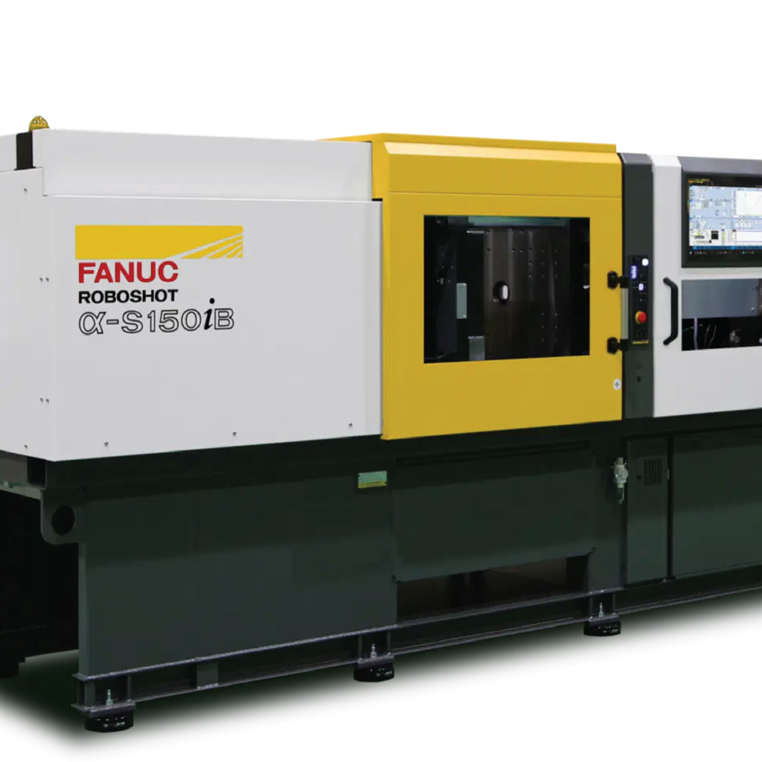
What is Plastic Molding?
Plastic molding is a manufacturing process where plastic materials are shaped into desired forms using molds. Through the application of heat and pressure, plastic can be molded into durable, intricate, and functional parts for diverse industrial uses.
The most common types of plastic molding include:
Injection Molding
Blow Molding
Compression Molding
Rotational Molding
Thermoforming
Each technique offers unique benefits depending on the design, volume, and material requirements of the project.
Why Choose FoxxTechnologies for Plastic Molding?
At FoxxTechnologies, we combine state-of-the-art technology with expert craftsmanship to ensure every molded product exceeds expectations.
Here’s what sets us apart:
Advanced Molding Equipment
High-Quality, Durable Materials
Custom Mold Design Services
Strict Quality Control Standards
Competitive Pricing and Timely Delivery
Our team of experienced engineers and technicians works closely with clients to understand their specific needs and deliver tailor-made solutions.
Industries We Serve
Our plastic molding services cater to a wide range of industries, including:
Automotive
Medical and Healthcare
Consumer Electronics
Packaging
Industrial Components
Contact FoxxTechnologies Today
If you’re looking for reliable and cost-effective plastic molding solutions, FoxxTechnologies is your trusted partner. Let’s bring your ideas to life with precision and efficiency.
Contact us : info@foxxtechnology.com
https://www.linkedin.com/company/foxxlifesciences
https://twitter.com/foxxlifescience
https://www.facebook.com/foxxlifesciences

