How to use social media to grow your brand in 2026 is no longer just about posting content—it’s about building authentic connections, using smart technology, and delivering personalized experiences. Brands that adapt to new platforms, AI-driven tools, and evolving user behavior will gain stronger visibility, trust, and long-term growth. Understanding how to use social media to grow your brand in 2026 is essential for staying competitive in the digital marketplace.

Focus on Authentic and Value-Driven Content
Audiences in 2026 prefer real, relatable, and meaningful content over overly polished promotions. Brands should focus on storytelling, behind-the-scenes posts, user-generated content, and problem-solving posts that provide genuine value. Authentic content helps build trust, increases engagement, and encourages long-term brand loyalty.
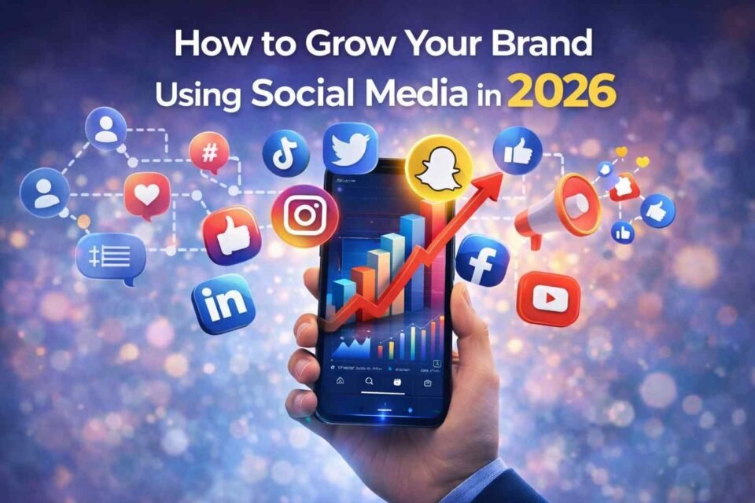

Leverage AI and Automation Smartly
Artificial intelligence plays a major role in social media growth in 2026. AI tools help analyze audience behavior, suggest optimal posting times, personalize content, and automate responses. When used strategically, AI allows brands to scale their efforts while maintaining a human touch in communication.
Prioritize Short-Form and Interactive Content
Short-form videos, interactive polls, live streams, and AR/VR experiences dominate social media platforms in 2026. Brands that invest in reels, shorts, stories, and immersive content formats can capture attention quickly and improve reach. Interactive content boosts engagement and helps brands stay memorable.

Build Strong Community Engagement
Growing a brand on social media in 2026 requires more than likes and shares—it’s about conversations. Responding to comments, engaging in DMs, creating exclusive groups, and encouraging audience participation strengthens community trust. A loyal community often becomes a brand’s strongest advocate.

Use Data and Social Commerce for Growth
Social media platforms in 2026 are powerful shopping ecosystems. Brands should use analytics to track performance and optimize campaigns while integrating social commerce features like in-app checkouts and product tags. Data-driven decisions help improve conversions and overall brand growth.

Collaborate with Niche Influencers
Influencer marketing continues to evolve in 2026, with a stronger focus on micro and niche influencers. Collaborating with creators who align with your brand values helps reach targeted audiences and improves credibility. Authentic influencer partnerships deliver higher engagement and better ROI.

Optimize Content for Search and Voice Discovery
Social media platforms are becoming search engines themselves. Using keywords, hashtags, and voice-search-friendly captions improves discoverability. Optimizing profiles and content for social SEO ensures your brand is easily found by the right audience in 2026.

Final Thoughts
Learning how to use social media to grow your brand in 2026 means embracing innovation, prioritizing authenticity, and staying connected with your audience. By combining AI tools, engaging content, community building, and data-driven strategies, brands can achieve sustainable growth and long-term success in the evolving social media landscape.
Contact Us : thallalokesh@gmail.com
Read More : https://www.thallalokesh.com/

