As artificial intelligence continues to evolve, branding strategies for 2026 with AI are transforming how businesses connect with their audiences. AI-powered branding goes beyond logos and visuals—it focuses on personalization, predictive insights, emotional engagement, and real-time brand experiences. Companies that embrace AI-driven branding in 2026 will gain stronger customer trust, loyalty, and competitive advantage.
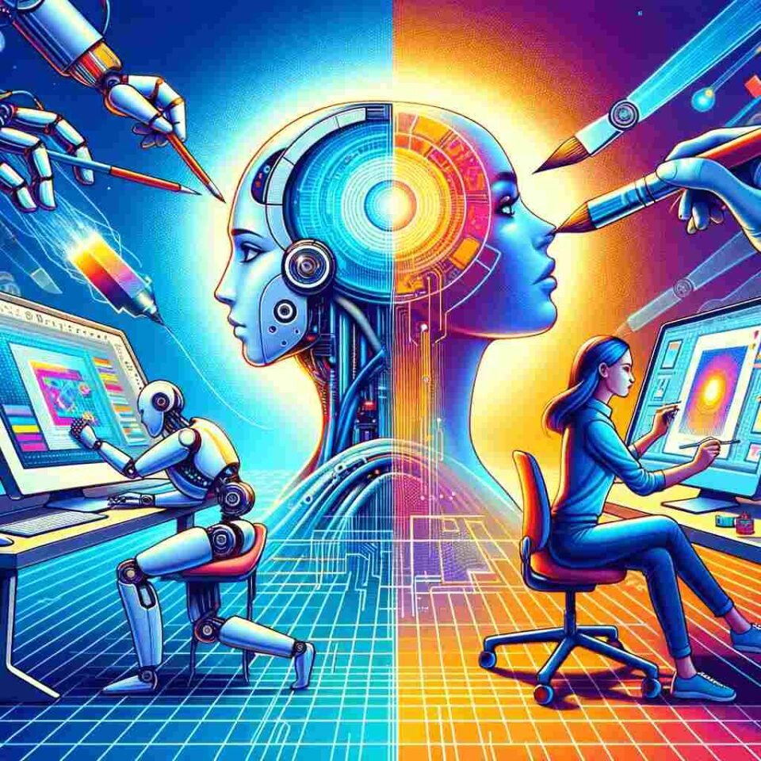
The Role of AI in Modern Branding
AI plays a central role in shaping brand identity and communication. Using machine learning and data analytics, brands can understand customer behavior, preferences, and emotions at scale. This enables businesses to deliver consistent and meaningful brand messages across multiple platforms while adapting quickly to changing market trends.
Hyper-Personalized Brand Experiences
One of the most important branding strategies for 2026 with AI is hyper-personalization. AI analyzes user data to create personalized content, product recommendations, and messaging. Brands can deliver tailored experiences for each customer, making interactions feel more human, relevant, and engaging.
AI-Driven Brand Storytelling
In 2026, storytelling powered by AI will redefine how brands communicate their values. AI tools can generate data-backed stories, adaptive narratives, and interactive content that evolves based on user responses. This allows brands to maintain authenticity while scaling their storytelling efforts across digital channels.
Predictive Branding and Trend Forecasting
AI helps brands anticipate future trends instead of reacting to them. Predictive analytics enables businesses to forecast customer needs, market shifts, and content performance. By adopting predictive branding, companies can position themselves ahead of competitors and remain relevant in fast-changing industries.
Visual Identity and Design with AI
AI-powered design tools are reshaping brand visuals in 2026. From logo variations to social media creatives, AI ensures visual consistency while optimizing designs based on audience engagement. This results in faster branding workflows and more impactful visual communication.
Ethical and Human-Centered AI Branding
Trust will be a key differentiator in branding strategies for 2026 with AI. Brands must use AI responsibly, focusing on transparency, data privacy, and human values. Ethical AI branding builds credibility and long-term relationships with customers who value authenticity and responsibility.
Omnichannel Branding Powered by AI
AI enables seamless omnichannel branding by maintaining consistent brand messaging across websites, social media, voice assistants, chatbots, and AR/VR platforms. In 2026, successful brands will use AI to unify all customer touchpoints into a single, cohesive brand experience.
Conclusion
Branding strategies for 2026 with AI are centered on personalization, predictive intelligence, ethical practices, and immersive experiences. By integrating AI into branding efforts, businesses can create smarter, more human-focused brands that resonate deeply with their audiences and thrive in the digital future.
Contact Us: thallalokesh@gmail.com
Read More : https://www.thallalokesh.com/

