SG777 Poker Rules – The Ultimate Guide to Playing Poker Online
Poker has been a favorite among casino players for decades, and the SG777 platform has brought the thrill of poker directly to your screen. Whether you’re a beginner learning the ropes or a seasoned player looking to sharpen your skills, understanding SG777 poker rules is the foundation of success.
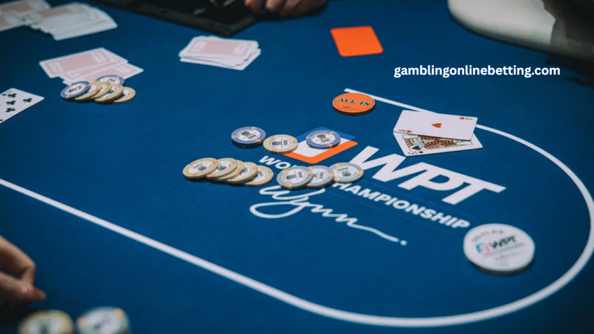
🎮 What is SG777 Poker?
SG777 Poker is an online version of the classic card game, offering different formats like Texas Hold’em, Omaha, and 7-Card Stud. The platform is designed for smooth gameplay, fair competition, and an immersive casino-like experience.
Knowing the rules is crucial because even the best strategies won’t work without a clear understanding of how the game flows.
🃏 Basic SG777 Poker Rules Step by Step
The Deal
Each player receives two private hole cards.
Five community cards are revealed in three stages: Flop (3 cards), Turn (1 card), River (1 card).
The Blinds
Poker uses small blind and big blind bets to initiate action.
These forced bets rotate around the table after each hand.
Betting Rounds
Pre-Flop – Players bet after receiving hole cards.
Flop – First three community cards are dealt.
Turn – Fourth card revealed; another betting round.
River – Fifth and final card is revealed.
The Showdown
Players reveal their cards.
The best five-card poker hand wins the pot.
🏆 Poker Hand Rankings on SG777
To master SG777 poker rules, you must know hand rankings:
Royal Flush – A, K, Q, J, 10 (same suit)

Straight Flush – 5 cards in sequence, same suit
Four of a Kind – 4 cards of the same rank
Full House – 3 of a kind + a pair
Flush – 5 cards of the same suit
Straight – 5 cards in sequence, different suits
Three of a Kind – 3 cards of the same rank
Two Pair – 2 pairs of cards
One Pair – 1 pair of cards
High Card – When no hand forms, the highest card counts
🎯 Advanced SG777 Poker Rules to Remember
Table Etiquette – Don’t delay the game unnecessarily.
All-In Rules – When a player bets all their chips, side pots are created if others continue betting.
Time Limits – SG777 tables often use time controls to keep the action moving.
Fair Play – Collusion and cheating are strictly prohibited; violators risk account suspension.
💡 Winning Strategies with SG777 Poker Rules
Play Tight-Aggressive – Stick to strong starting hands but play them aggressively.
Use Bluffing Sparingly – A well-timed bluff works, but overuse makes you predictable.
Position is Power – Being the last to act gives you more information to decide wisely.Bankroll Management – Decide how much you can risk before sitting at a table.
Study Your Opponents – Notice betting patterns; SG777 poker is as much about reading people as about the cards.
📱 Why Choose SG777 for Poker?
24/7 Games – Play anytime, anywhere.
Global Players – Compete with poker lovers worldwide.
Tournaments – Join exciting competitions with huge rewards.
Safe & Secure – SG777 ensures fair play with encrypted systems.
❓ FAQs on SG777 Poker Rules
Q1: Can beginners play poker on SG777?
Yes! SG777 offers beginner-friendly tables where you can practice poker rules risk-free.
Q2: What is the minimum hand to win?
A simple high card can sometimes win if opponents don’t have pairs or better.
Q3: Is SG777 Poker legal?
SG777 operates online as a gaming platform. Always check your local laws before playing with real money.
Q4: Can I play SG777 Poker on mobile?
Yes, SG777 poker is optimized for mobile and desktop, giving you flexibility to play anywhere.
📌 Final Thoughts
Understanding the SG777 poker rules is the first step to becoming a confident player. Once you master the basics, you can build advanced strategies, join tournaments, and even compete at a professional level. Remember: poker is not only about the cards you hold but also about how you play them.

