SolarMovie Proxy — Risks, How It Works, and Legal Alternatives

Short version: SolarMovie was (and its many clones are) an online movie streaming network known for hosting pirated films and TV shows. When main SolarMovie domains get blocked, users often search for SolarMovie proxies or mirror sites to regain access — but those proxies carry legal, ethical, and security risks. This guide explains what a SolarMovie proxy is, why people look for them, the dangers involved, and safer legal alternatives.
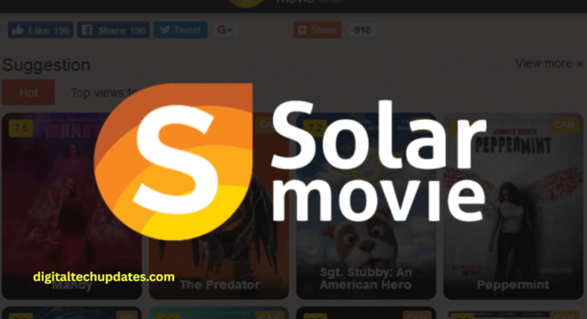

What is (or was) SolarMovie?

SolarMovie was a popular streaming/indexing site that offered free access to movies and TV shows—often without proper licensing. Like many piracy hubs, when original domains were taken down or blocked, copycat sites, mirror domains, and proxies popped up to offer the same content under different URLs.

What is a “proxy” or “mirror” site?

Proxy / mirror: a site that replicates another site’s content or acts as a gateway to a blocked website so users can still access it.

Operators launch new domains or mirrors whenever hosting providers, ISPs, or authorities block a SolarMovie URL.

Technically they’re just alternative entry points — but the content they expose is typically the same unlicensed material.

Why people search for SolarMovie proxies

Free access to new releases without subscription fees.

Quick uploads of regional and international content.

No sign-up or payment needed.
(These are convenience reasons — not legal justification.)

The real risks of using SolarMovie proxies
1. Legal risk

Accessing or downloading copyrighted material without permission can be illegal in many countries. Even if enforcement varies, users may receive warnings, fines, or other penalties depending on local laws.

2. Security risks

Many proxy/mirror sites are laden with intrusive ads, fake download buttons, pop-ups, tracking scripts, or malware. Clicking the wrong link can lead to:

Adware, spyware, or ransomware infections

Phishing pages that steal credentials or payment data

Drive-by downloads that infect devices silently

3. Privacy risk

Some proxy sites log user activity, collect IPs, or ask for unnecessary permissions. That data can be sold or misused.

4. Unreliable & low quality

Mirror sites tend to be unstable, frequently go offline, and offer poor-quality video, broken links, or misleading pages.

5. Ethical & industry impact

Piracy reduces revenue for filmmakers, cast, crew, and distribution channels. Over time, it harms the incentives to produce content.

How proxies work (brief, non-technical)

Original site gets blocked/taken down.

Operators spin up a new domain (or copy content to mirrors).

Users find the new URL via search or social sharing.

Ads & affiliate links monetize traffic — often at the user’s expense.

How to spot harmful proxy/mirror pages (red flags)

Excessive pop-ups or “Download” buttons that open other sites.

Requests to install strange browser extensions or apps.

Pages asking for login credentials to “verify” age or region.

Domains with weird extensions or long random strings...

“Too good to be true” claims like “watch new releases same day free.”

Safer, legal alternatives (recommended)

If you want to watch movies and support creators, consider these options:

Paid OTTs: Netflix, Amazon Prime Video, Disney+ / Hotstar, HBO Max, Hulu (regional availability varies).

Ad-supported legal services: Tubi, Pluto TV, Crackle, MX Player (region-dependent).

Rent / buy: Google Play Movies, Apple iTunes, YouTube Movies.

Library & free legal: Kanopy, Hoopla (via library membership).
These options are safer, higher-quality, and ensure creators are paid.

Quick user safety checklist

Don’t click suspicious “download” buttons.

Keep OS and antivirus up to date.

Avoid installing browser extensions from unknown sources.

Use legal services to protect privacy and avoid legal exposure.

FAQs

Q: Are SolarMovie proxies illegal?
A: The proxies themselves are typically legal/illegal depending on jurisdiction and what they host/serve. However, using them to access copyrighted content without permission is generally illegal or at least breaches copyright in many countries.

Q: Can I get malware from mirror sites?
A: Yes. Fake links, adware, and malicious downloads are common on piracy mirrors.

Q: Are there any legal ways to watch new releases for free?
A: Sometimes—via limited-time free promos, free tiers on ad-supported services, library streaming, or free trials from reputable providers. Always check official channels.

Final thoughts

Searching for a SolarMovie proxy might look like a quick way to watch something for free, but the downsides are steep: legal exposure, device compromise, privacy invasion, and the ethical cost to creators. For a safer, more reliable, and guilt-free experience, choose licensed platforms or legitimate free services.

